**Git and Github**

1. 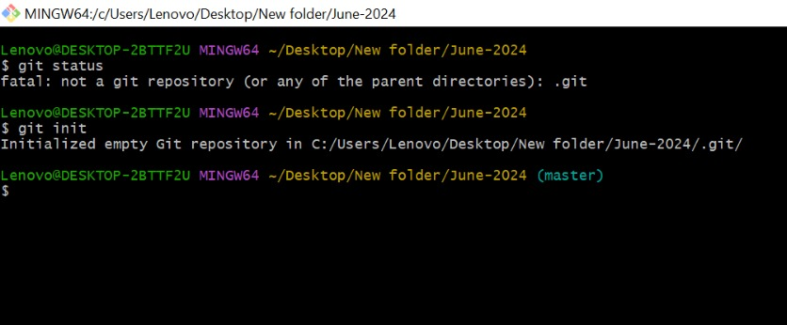Git initialize

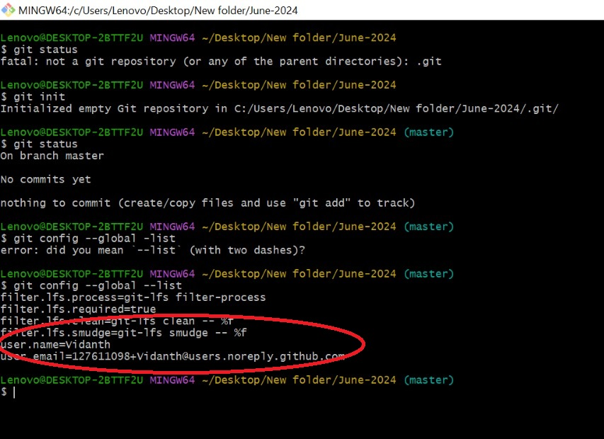2. Git configuration

1. Git conflict

git conflict-01 from creating f1 to changes done in feature1 branch

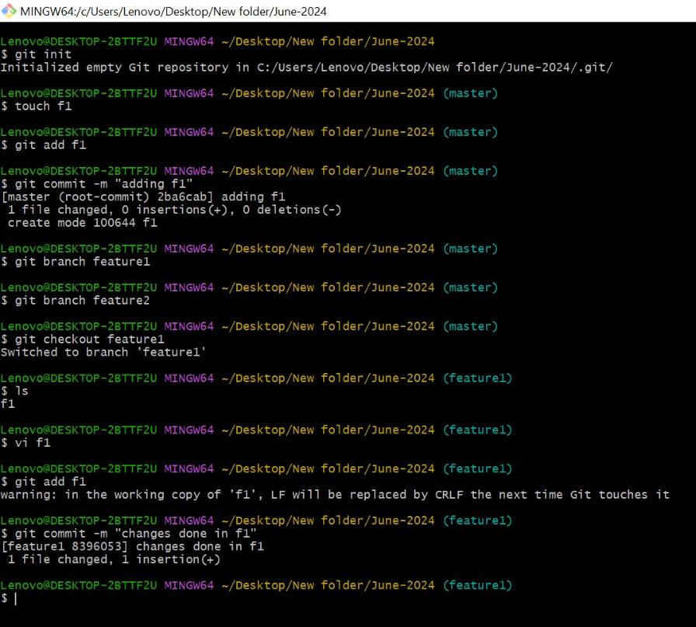

git conflict -02 feature1 merge to master

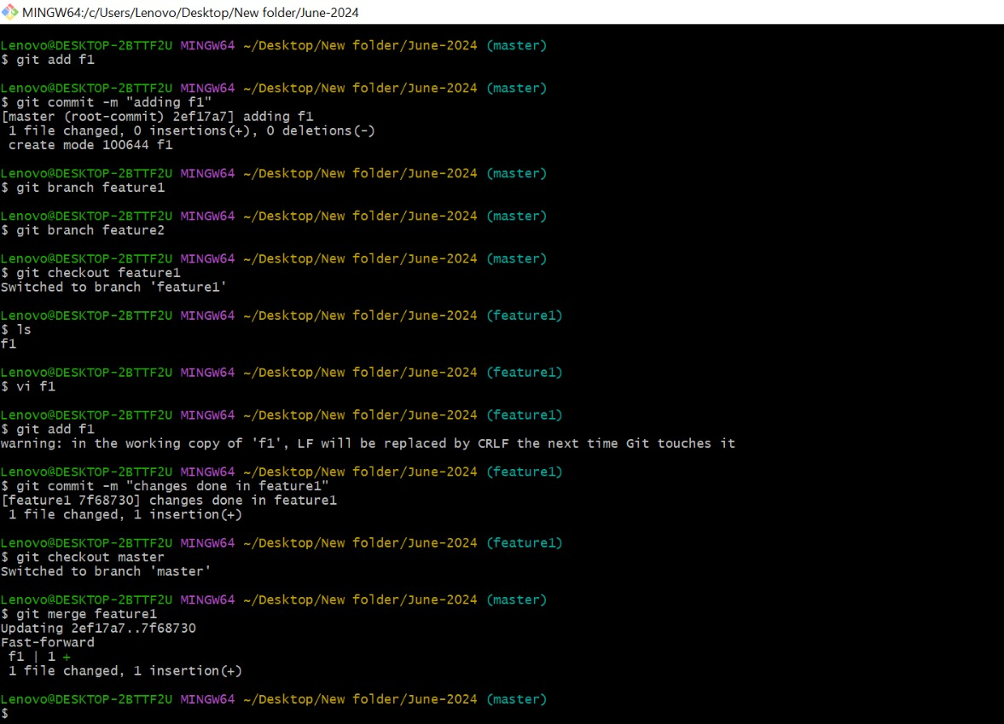

git conflict-03 changes done in feature2 branch



git conflict-04 error occur while doing feature2 merge to master branch

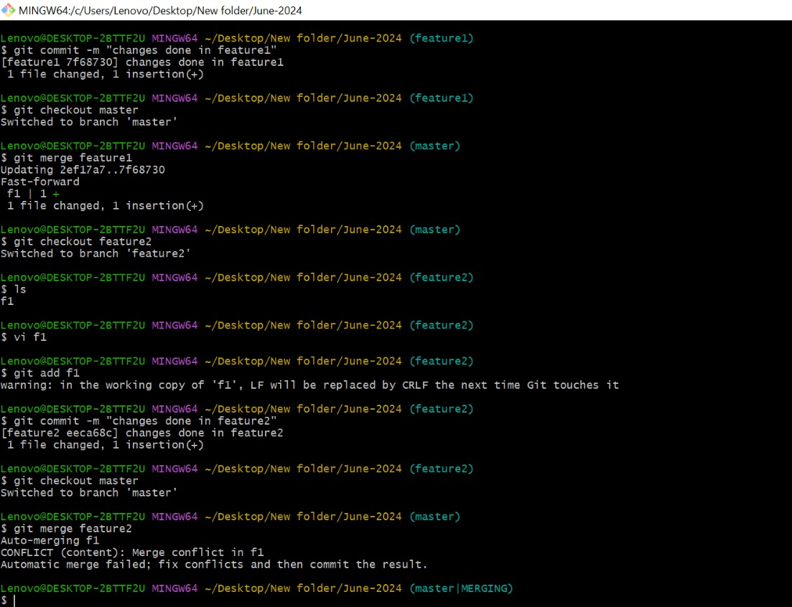

1. Git clone

git clone-creating & copying a SSH key

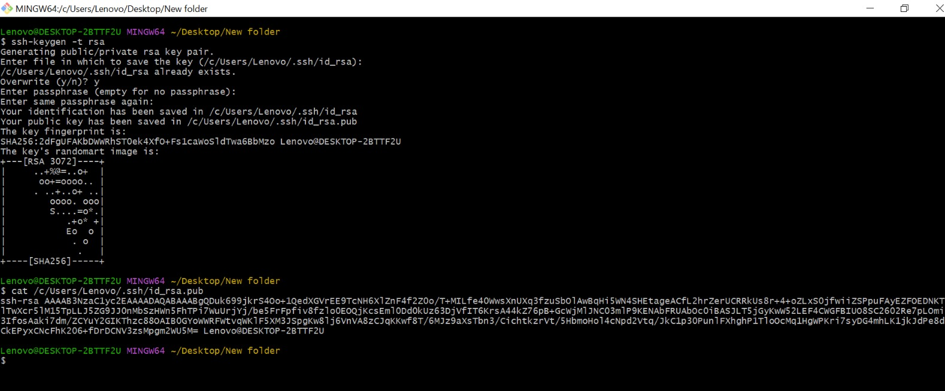

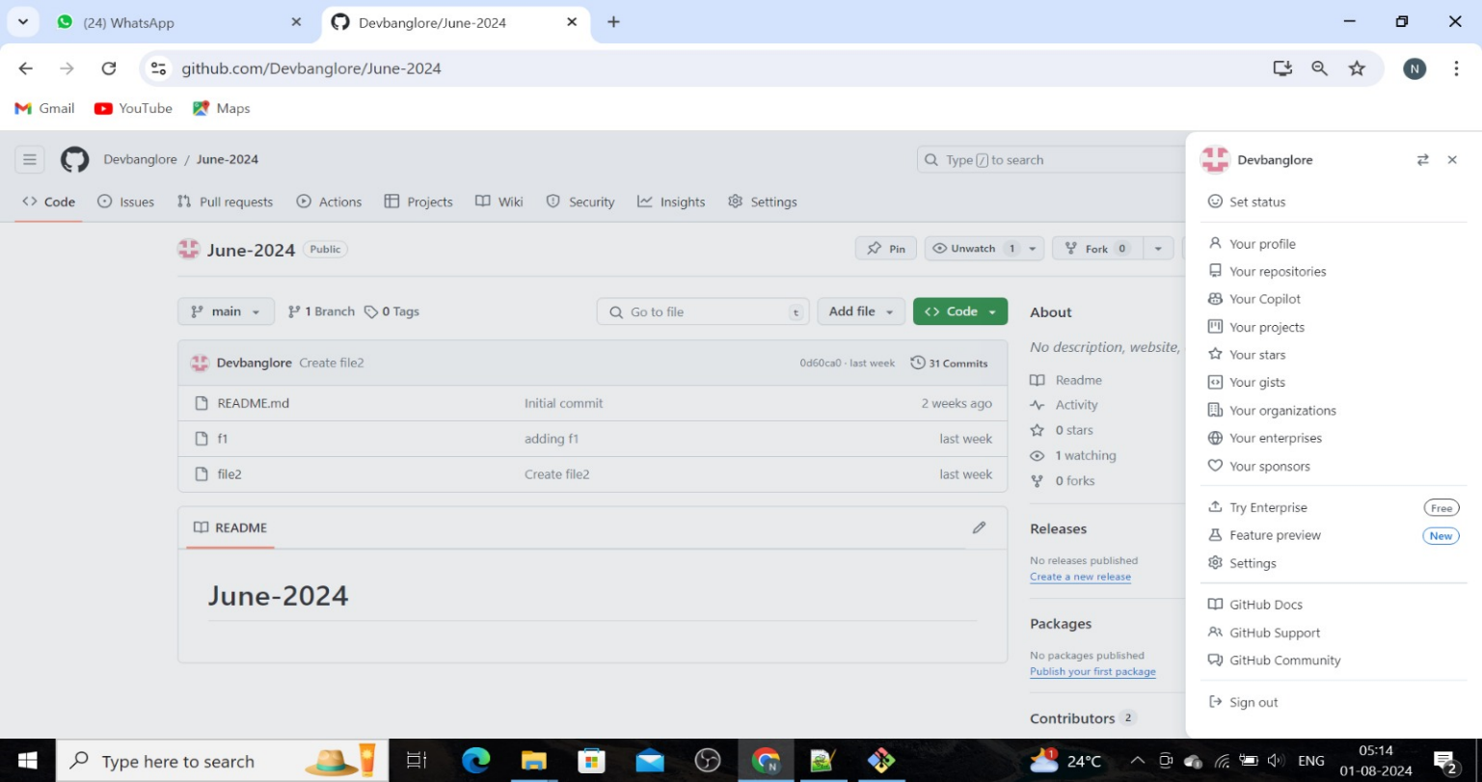git clone-go to the settings

git clone-click on ssh and GPG key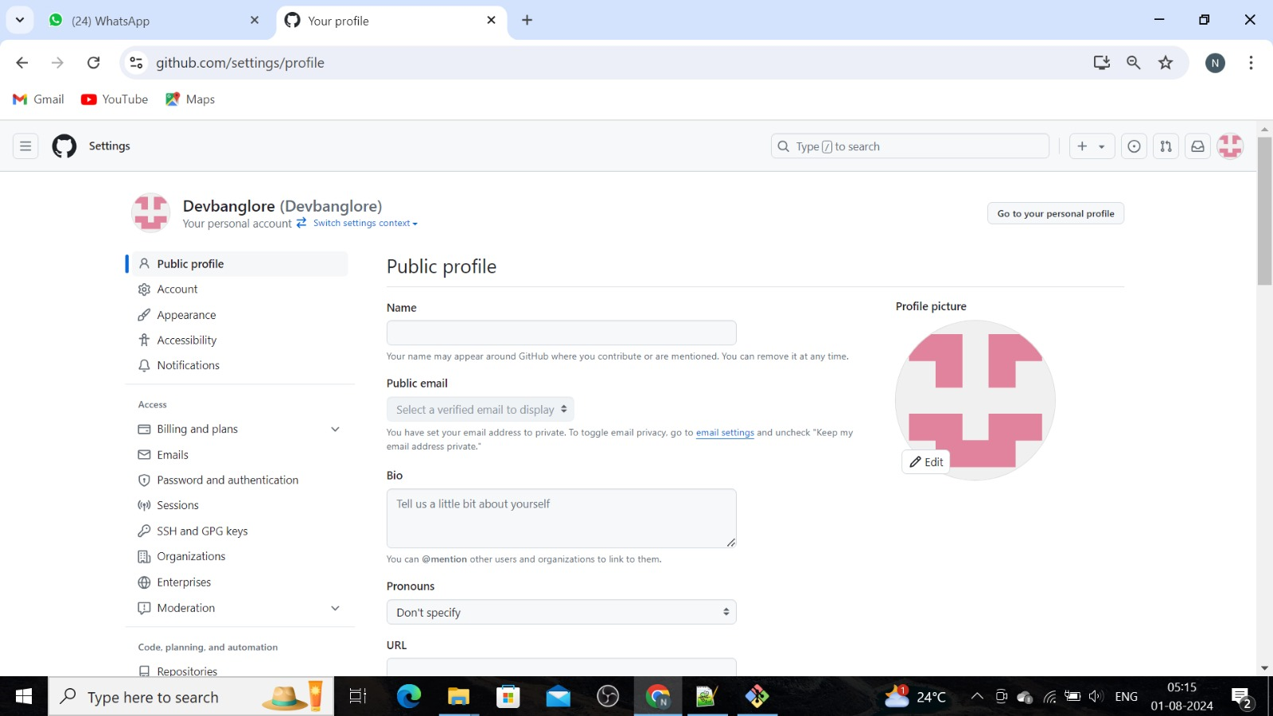

git clone-giving title name and copy the ssh key

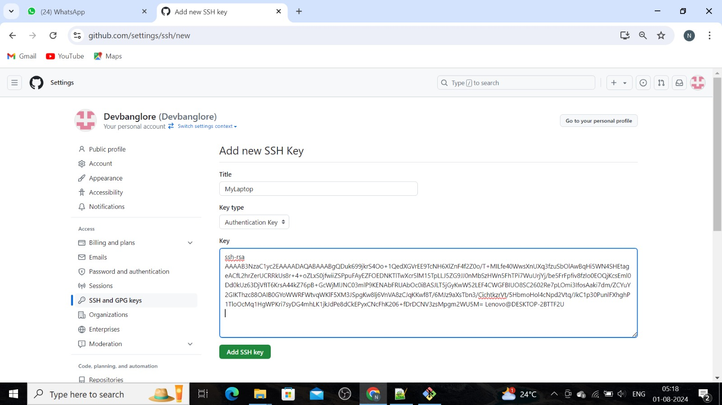

git clone-go to repo dashboard, click on code and copy the ssh URL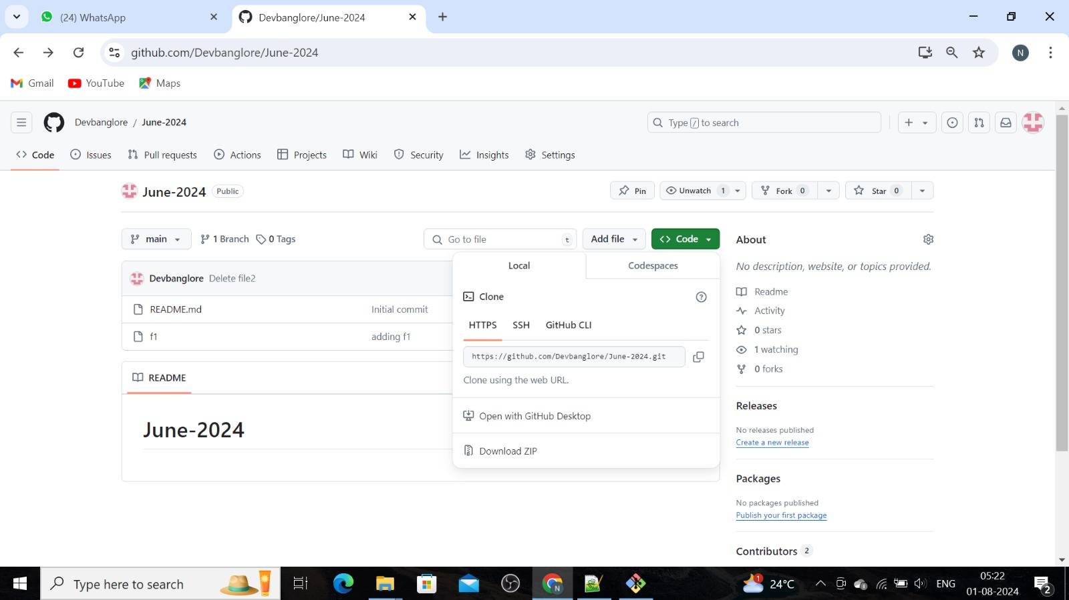

git clone-cloning using ssh URL..

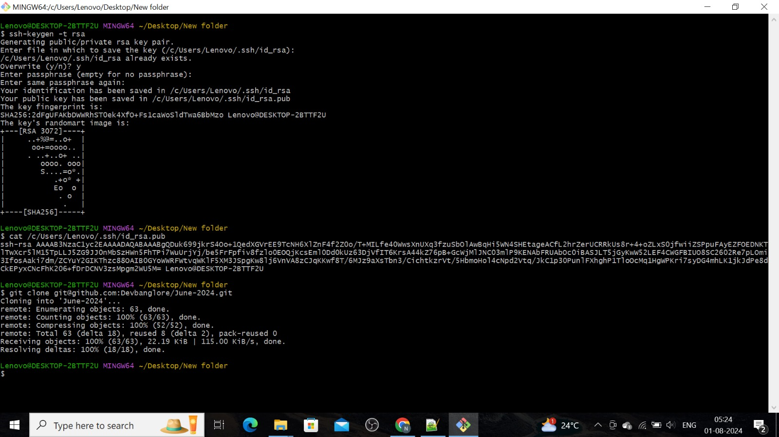

* Git cherry-pick – It is used pull the particular commit ID and it will change previous commit of the file.

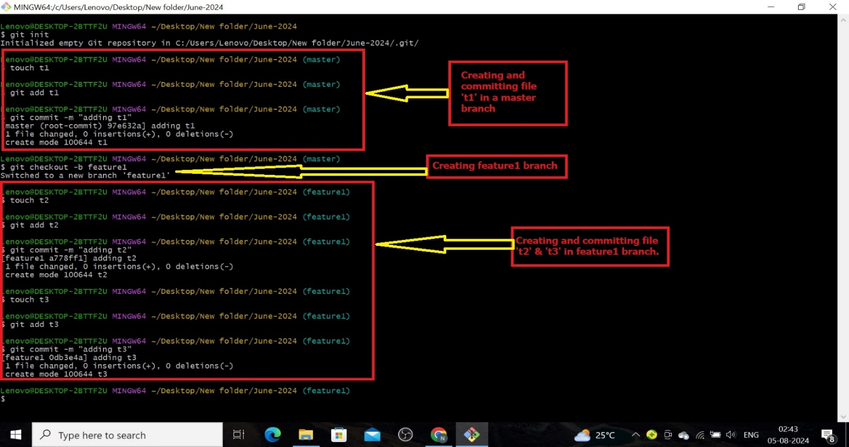Follow the steps to use the git cherry-pick

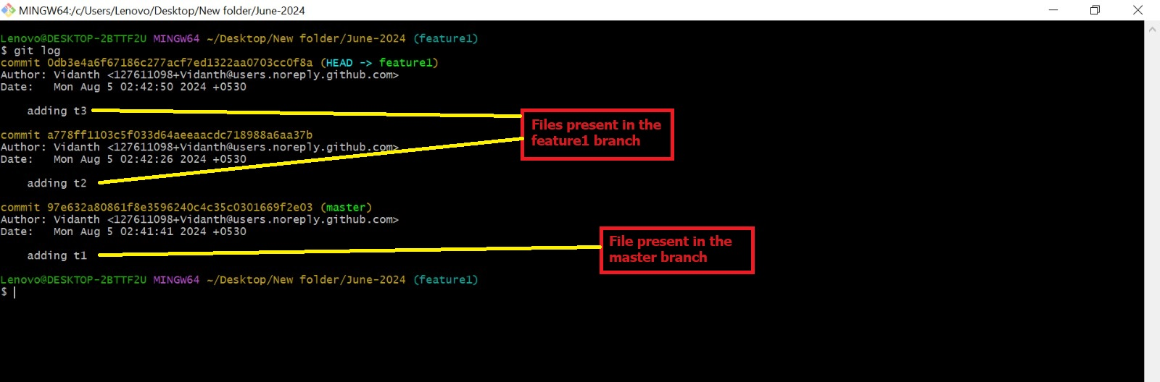

* Git squash – Git squash is used to reduced the commit IDs or squash the IDs.

Command is – git rebase -i HEAD~3 (3 – latest commit IDs)

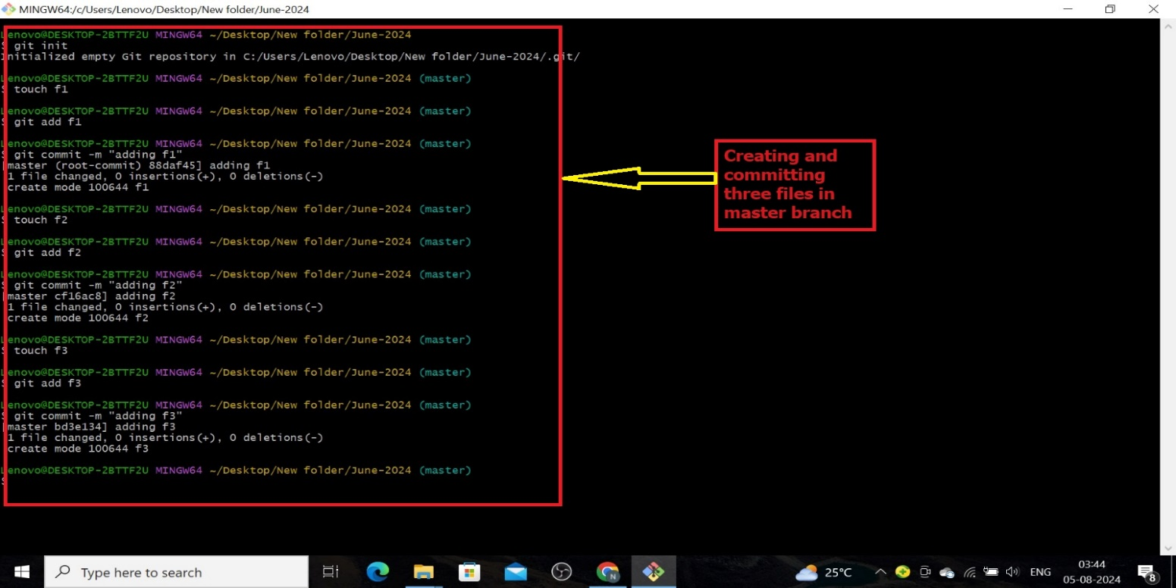Just follow the below steps to execute the squash command.

